|  |  |  |  |  |  |  |  |  |
| --- | --- | --- | --- | --- | --- | --- | --- | --- |
| Index | Domain size | Grid | Particle density: Pcs/m2 | | | Flux: pcs/m2.s | | |
| FCS X | FCS Y | FCS Z | FCS X | FCS Y | FCS Z |
| 1 | 360 m x 160 m x 120 m | 2 m | 29 | 180 | 552 | 0.071 | 0.350 | 1.399 |
| 2 | 360 m x 160 m x 120 m | 1m | 18 | 100 | 722 | 0.045 | 0.196 | 1.832 |
| 3 | 360 m x 160 m x 180 m | 2 m | 16 | 224 | 585 | 0.040 | 0.436 | 1.484 |

Firebrand collection area 10 m x 10 m

Firebrand collection area 2 m x 2 m

|  |  |  |  |  |  |  |  |  |
| --- | --- | --- | --- | --- | --- | --- | --- | --- |
| Index | Domain size | Grid | Particle density: Pcs/m2 | | | Flux: pcs/m2.s | | |
| FCS X | FCS Y | FCS Z | FCS X | FCS Y | FCS Z |
| 4 | 360 m x 160 m x 120 m | 1m | 35 | 494 | 643 | 0.086 | 0.963 | 1.632 |
| 5 | 360 m x 160 m x 180 m | 2 m | 14 | 919 | 589 | 0.034 | 1.791 | 1.495 |

Experiment collection area 1.83 m2

|  |  |  |  |  |  |  |  |  |
| --- | --- | --- | --- | --- | --- | --- | --- | --- |
| Index | Domain size | Grid | Particle density: Pcs/m2 | | | Flux: pcs/m2.s | | |
| FCS X | FCS Y | FCS X | FCS X | FCS X | FCS Z |
| Exp | NA | NA | 335 | 463 | 536 | 0.824 | 0.902 | 1.361 |

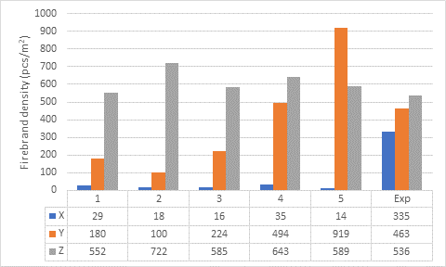

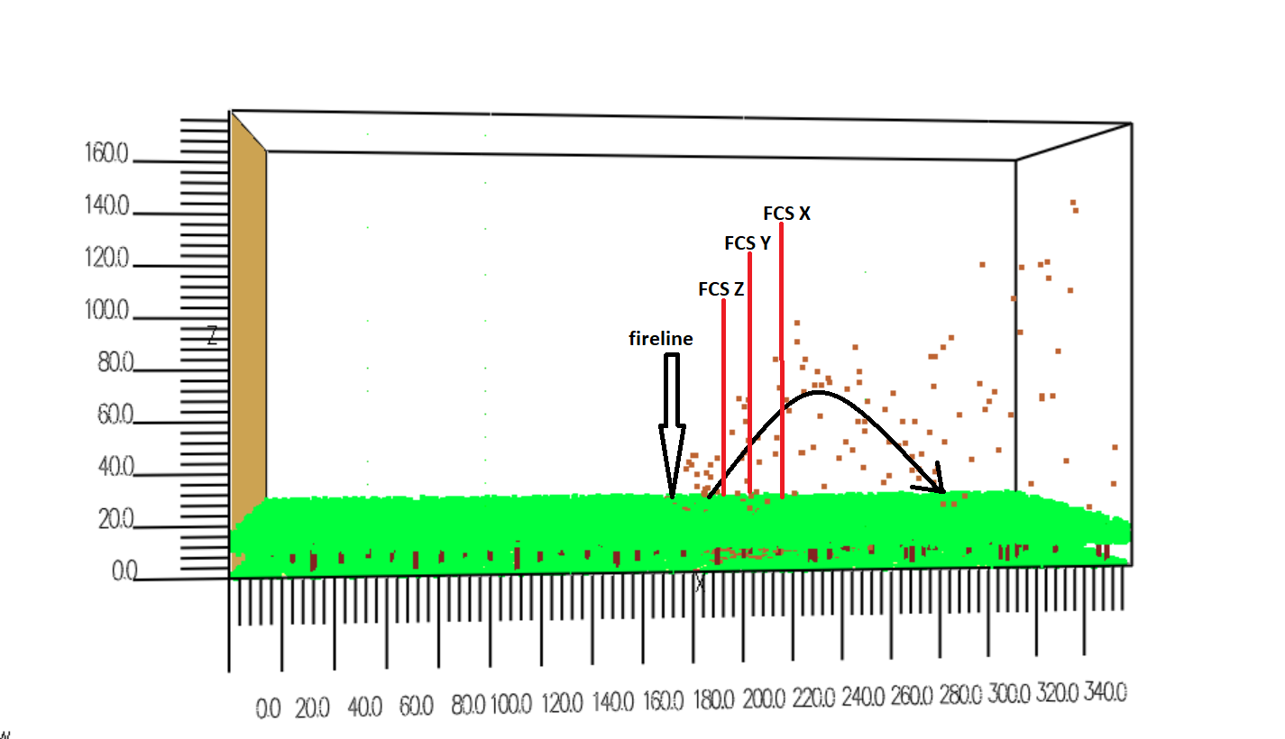

According to above results, I see it affects the grid size considerably for firebrand distribution and it is important the size of the firebrand collection device and its location.

Input number of firebrand vs fire intensity

1. Single tree burning

Average heat release rate (2 seconds to 34 seconds) = 1602 kW

Number of total input firebrands = 347

Average input firebrands (2 seconds to 34 seconds) = 10. 52 pcs/s

Input number vs HRR = $\frac{input number of firebrands}{HRR}$

= $\frac{10.52 pcs}{1.602 MW}=6.565 pcs/MW$

Mass flux on collection pans = $\frac{total mass collected}{number of pans ×area of a pan ×collection time}$

Mass flux on collection pans = $\frac{18.63 g}{13 ×\left(0. 5 m ×0.3 m\right) ×40 s}=0.2388 \frac{g}{m^{2}.s}$

1. Forest burning

Average heat release rate =2401 MW (27 s to 140 s)

Fire intensity and input number of firebrands



Fireline length =130 m

Fire line depth = 2 m

Fireline intensity =18.46 MW/m



Firebrands input volume = 2m x 130 m x 9 m = 2340 m3

Input number of firebrands = 7223 pcs/s

Input number vs HRR = $\frac{input number of firebrands}{HRR}$

= $\frac{7223 pcs}{2401 MW}=3.008 pcs/MW$

Mass flux on collection pans = $\frac{total mass collected}{number of pans ×area of a pan ×collection time}$

Mass flux on collection pans = $\frac{1.28 ×{10}^{3}g}{3 ×100 m^{2}×104 s}=0.041 g/m^{2}$.s

|  |  |  |
| --- | --- | --- |
| simulation | Pcs vs intensity (pcs/MW) | Landing flux (in terms of mass) (g/m2. s) |
| Single tree | 6.565 | 0.2388 |
| Forest fire | 3.008 | 0.0411 |

pcs/MW

Single tree is **2 times** than the forest fire.

Landing flux

Single tree is **6 times** than the forest fire.

**Drag Models**

Total firebrand mass collected in FDS default cylindrical drag model = 18.630g

Total firebrand mass collected in Haider and Levenspiel drag model = 21.776g

Difference = $\frac{(21.776 g-18.630 g)}{18. 630g}$

=16.88%

Firebrand distribution on pans has been varied.

|  |  |  |  |  |  |  |  |  |
| --- | --- | --- | --- | --- | --- | --- | --- | --- |
| Default drag model | | | | Haider and Levenspiel drag model | | | | difference |
| collected firebrand mass (g) | | | 18.6304 | collected firebrand mass (g) | | | 21.77603 | 17% |
| pan | mass (g) |  |  | pan | mass(g) |  |  |  |
| 1 | 1.454918 |  |  | 1 | 1.087957 |  |  | 25% |
| 2 | 3.173469 |  |  | 2 | 1.592915 |  |  | 50% |
| 3 | 0.530189 |  |  | 3 | 1.194635 |  |  | -125% |
| 4 | 0.713864 |  |  | 4 | 2.609649 |  |  | -266% |
| 5 | 3.640811 |  |  | 5 | 1.306113 |  |  | 64% |
| 6 | 0.657941 |  |  | 6 | 0.642411 |  |  | 2% |
| 7 | 0 |  |  | 7 | 0.484055 |  |  |  |
| 8 | 1.937063 |  |  | 8 | 1.143373 |  |  | 41% |
| 9 | 1.872409 |  |  | 9 | 2.43433 |  |  | -30% |
| 10 | 2.819354 |  |  | 10 | 1.757598 |  |  | 38% |
| 11 | 0.861483 |  |  | 11 | 4.340472 |  |  | -404% |
| 12 | 0.642099 |  |  | 12 | 3.002016 |  |  | -368% |
| 20 | 0.234904 |  |  | 20 | 0 |  |  | 100% |
| 34 | 0.091901 |  |  | 34 | 0 |  |  | 100% |
| 55 | 0 |  |  | 55 | 0.180506 |  |  |  |